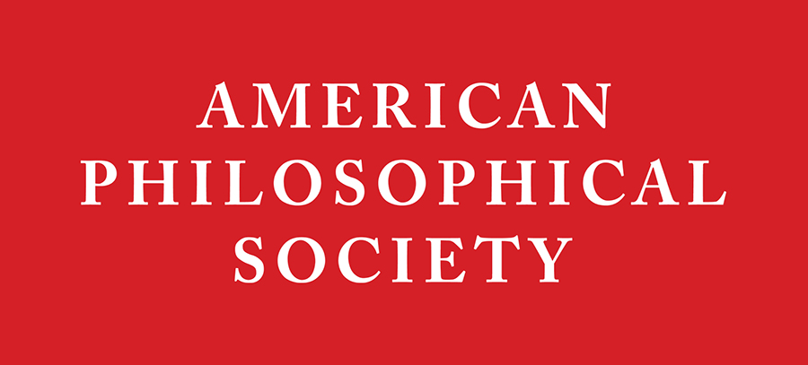
American Philosophical Society
Andrew W. Mellon Foundation
Post-Doctoral Curatorial Fellowship 2018-2020

APPLICATION DEADLINE IS NOVEMBER 27, 2017
APPLICANT INFORMATION
Salutation:
First Name:
Middle Name/Initial:
Last Name:
Primary Email Address:
Work Phone:
Cell Phone:
Home Address:
City/State:
Zip/Postal Code:

EDUCATION
PhD Degree received from:
Date received (or to be received):
Title of Doctoral Dissertation:
Name of Academic Supervisor:
Primary Discipline:
Secondary Discipline(s) or Area(s) of Expertise:
Museum Experience, if any:

APPLICATION DEADLINE IS NOVEMBER 27, 2017.

APPLICATIONS MUST BE EMAILED TO: MellonFellowship@amphilsoc.org

SUBJECT LINE OF EMAIL: Last Name, First Name - Mellon Application 2018-20
REQUIRED MATERIALS/CHECKLIST
- Cover letter stating interest in exploring curatorial work.
- Completed application form.
- Comprehensive curriculum vitae, with items listed within categories in reverse chronological order (include external support received during graduate study: fellowships, teaching or research assistantships, tuition grants, etc.).
- Statement of current research interests (no more than 1,500 words). This statement should include a description of a potential personal research project to work on during the Fellowship, preferably one related to the APS collections or programs.
- Excerpt(s) from dissertation (no more than 5,000 words). An excerpt from a working draft is acceptable.
- Example of non-scholarly writing, if available.
- A letter from a Department Chair or Director of Graduate Studies (or equivalent) confirming that the applicant will complete their PhD by the required date.
- Three confidential letters of recommendation, which must be submitted with the APS recommendation form provided at http://www.amphilsoc.org/grants/curatorialfellowship Please see instructions in next section.

LETTERS OF RECOMMENDATION
Three confidential letters of recommendation using the APS recommendation form are required. Recommenders must use the form online at http://www.amphilsoc.org/grants/curatorialfellowship and email the completed form and letter directly to MellonFellowship@amphilsoc.org. It is the applicant’s responsibility to ensure that recommenders use the APS form and that the letters are received by the November 27, 2017 deadline. Please do not include recommendation letters with the application.

The three recommendations should include one from the applicant’s dissertation advisor and one from a supervisor of the applicant at a museum or other such employer, if applicable. The third letter is at the discretion of the applicant.
- Name:
Title:
University:

- Name:
Title:
University:

- Name:
Title:
University:

ADDITIONAL QUESTIONS
Please let us know how you found out about this Fellowship. Where else would you recommend that we list it? :

Please identify your primary racial / ethnic group, using U.S. census categories (check all that apply):
☐ Asian
☐ Black or African American
☐ American Indian and Alaska Native
☐ White
☐ Native Hawaiian or Other Pacific Islander
☐ Hispanic or Latino
☐ Other (Please specify):

